WE XPLORE. WE XCITE. WE XIST. WE ARE ULYSSE

THE UNIQUE CASE OF CARBONIUM®
“Nothing is created, nothing is lost, everything is transformed.”

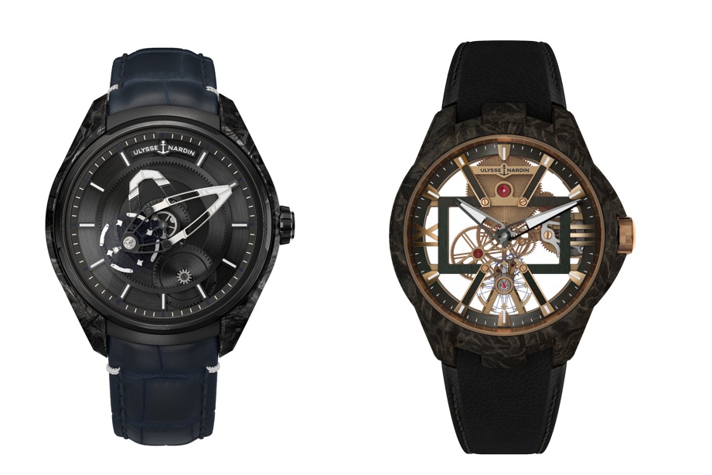

January 2019, Geneva - Inside and out, the X Collection by Ulysse Nardin boldly pushes watchmaking convention into exciting new regions of creativity and aesthetics. Nowhere is this more apparent than in its pioneering use of Carbonium ®, a high-performance composite material heretofore only used by aeronautical engineers. Not only is Carbonium ® super tough, with an exceptional resistance-to-lightness ratio, its marbled waves of brilliant and matte layers give it a vibrant fluidity that delights the eye and makes each watch case look absolutely unique.

Carbonium® is composed of the aeronautical grade carbon fibers used to make vital structural parts of modern aircraft. It is roughly twice as light as aluminum and twice as environmentally friendly as conventional carbon composite. This is because, unlike most composites, it is not made of virgin materials; 95% of it is eco-sourced from carbon by-products in the aeronautical cycle.

The innovative process development used to up-cycle aerospace grade carbon material is based on three patents led by its France-based start-up company, Lavoisier Composites.
The result is a carbon-based composite material of unprecedented mechanical performance with a much reduced environmental footprint.

Equally important, Carbonium® is aesthetically stunning. The process uses high pressures and temperatures to reveal the core beauty of the organic pattern created by carbon fibers. This offers Ulysse Nardin designers a rich palette of possible combinations with precious metals and pigments. Carbonium® Gold, for example, is the intimate “fusion” of 7 μm carbon filaments and dispersed gold particles within a thermosetting matrix, which creates a veined gold effect whose singularity and finesse are wholly unique.

Whether classic grey or gold, every Carbonium® case in the X Collection is a one-off work of art. As always, Ulysse Nardin is pioneering in watchmaking, shaking things up by pushing boldness and creativity to the max, creating awe-inspiring wonders for the adventurous minded - those few, rare, modern-day Ulysses who look beyond the known horizon, and strike out on their own.

Link to the press room: https://www.ulysse-nardin.com/press/

Follow us

Facebook : https://www.facebook.com/UlysseNardinwatches/
Instagram : http://www.instagram.com/ulyssenardinofficial
Twitter : https://twitter.com/ulysse_nardin
#weareulysse

About Ulysse Nardin – Manufacture of Freedom

Ulysse Nardin is the Pioneering Manufacture inspired by the sea and delivering innovative timepieces to free spirits.
Founded by Mr. Ulysse Nardin in 1846 and a proud member of the global luxury group Kering since November 2014, Ulysse Nardin has written some of the finest chapters in the history of Haute Horlogerie. The company’s earliest renown came from its links to the nautical world: its marine chronometers are among the most reliable ever made, still sought by collectors around the world. A pioneer of cutting-edge technologies and the innovative use of materials like silicon, the brand is one of the few with the in-house expertise to produce its own high-precision components and movements. This exceptional level of watchmaking excellence has earned Ulysse Nardin membership in the most exclusive circle of Swiss watchmaking, the Fondation de la Haute Horlogerie. Today, from its sites in Le Locle and La Chaux-de-Fonds in Switzerland, the brand’s continuing quest for horological perfection centers around five collections: The Marine, the Diver, the Classico, the Executive and the Freak. In 2019, Ulysse Nardin introduces the X-factor in watchmaking. www.ulysse-nardin.com

